**6/4/2020**

GAIT – Gaming product review website

(<http://gaitnsu.000webhostapp.com/>)

**Course: CSE482.2**

**Submitted by:**

|  |  |
| --- | --- |
| **Name** | **ID** |
| Ishrat Jahan Ananya | 1631636042 |
| Md. Farhanuzzaman Reza Famous | 1510303042 |
| Sazid Alam | 1511394042 |
| Abul Morshed Arif | 1521478042 |

# Table of Contents

Introduction……………………………………………………………………………………………………………………….3

Background……………………………………………………………………………………………………………………….3

Use case model…………………………………………………………………………………………………………………3

Solution Description…………………………………………………………………………………………………………..4

Architecture……………………………………………………………………………………………………………………..5

Front-end………………………………………………………………………………………………………………………….5

Back-end…………………………………………………………………………………………………………………………….5

Development Plan…………………………………………………………………………………………………………….6

Hosting Plan……………………………………………………………………………………………………………………..7

Colaboration plan……………………………………………………………………………………………………………..7

Project Schedule…………………………………………………………………………………………………………………7

Conclusion…………………………………………………………………………………………………………………………8

# Introduction

This document presents a detailed description of GAIT – a gaming product review website. It explains the project in brief, the features implemented, the navigation of the user interface and finally the limitations and future-proofing aspects of this project. Furthermore, it mentions the development plan for the project phase by phase of over a time frame of three months.

# Background and Product Context

There is a gigantic number of people that spend a large sum of money on games and gaming products. Hence there is a huge market for items like gaming cards, game pads, mouse, keyboards etc. With so many options to choose from, it gets difficult to narrow down our choices that fit best with our requirements. More often than not, it is a tedious, research extensive process.

The solution to the problem is GAIT. The objective of this project is to create a web application that helps the user to choose the right product according to their preference. This cuts down on the time-consuming work put into searching the whole internet and asking around for reviews that would ultimately affect your purchase decision. Gait hosts a vast collection of gaming products with their details and authentic reviews by users. It also includes ratings for every item. This allows other users to fill in their requirements, including the budget and discover the best option for them based on user reviews.

Moreover, there is an option for premium memberships. User can pay a subscription fee to get special features such as advertising their own product etc.

# Use Case Model

## Use Case 1: Registration

**Actor** – User

**Purpose** – user can create a new account on the website by providing an email address and password or use their google account.

**Condition** – none

## Use Case 2: Login

**Actor** – User

**Purpose** – user can request to login to their account. Once the system validates the user’s email and password they can be logged into the website.

**Condition** – user must be registered

## Use Case 3: Search for product

**Actor** – User

**Purpose** – user can search for any gaming item in search bar of their homepage. The option to choose from similar items appear from which user can select any to view details of the product and compare reviews.

**Condition** – user must be logged in

## Use Case 4: Write Review

**Actor** – User

**Purpose** – User can post a picture of any gaming product or accessories, fill in the details of the product and write a review on it for others to see.

**Condition** – user must be logged in

## Use Case 5: Add/Delete reviews

**Actor** – Admin

**Purpose** – Admin has the option to view user activity and add or delete any reviews or products that violates product policy.

**Condition** – admin must be logged in

## Use Case 6: Add Product Review

**Actor** – User

**Purpose** – User can add their own product and its details on the website

**Condition** – user must have premium membership

# Solution description

## Architecture

The frontend is a series of webpages developed with HTML, CSS, JavaScript and Bootstrap. The back end consists of a database to contain all the information such as product details, user account details etc. The database is be handled using mysql and php. A payment method has also been incorporated using Stripe API for premium membership of the users who would receive extra benefits.

## Front-end development

The front end comprises of 4 pages in total. The homepage of the website, the registration page, the login page and the admin page forms the skeleton of the website. The following are a few snapshots of the website

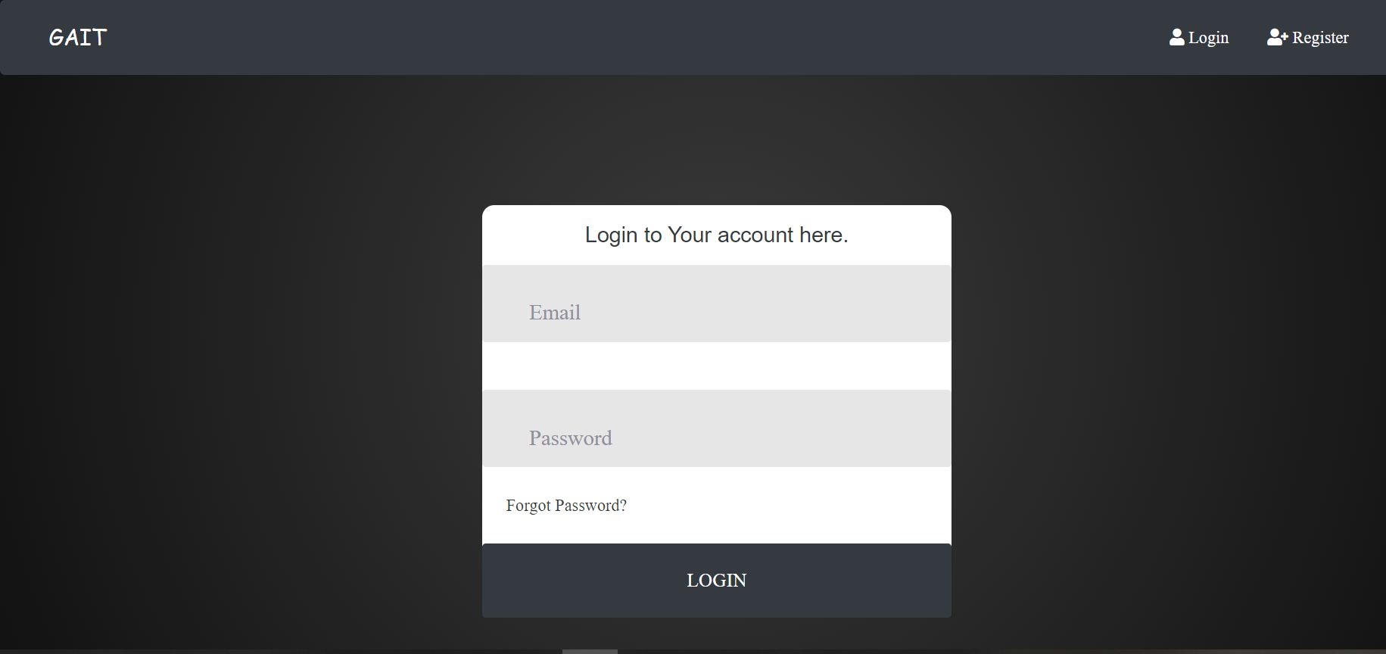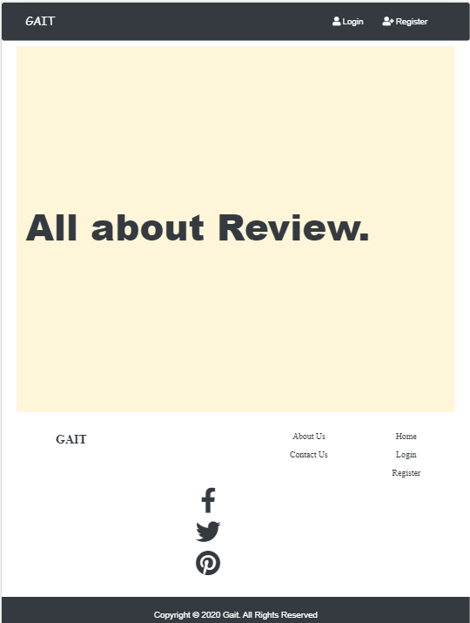

The UI also includes product page, product detail page and user’s dashboard page. Ajax has also been implemented to make the searching feature more efficient. The products can be searched by name or category.

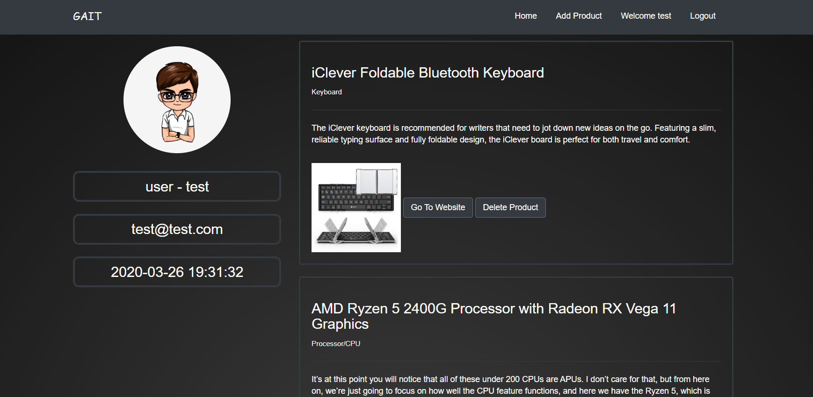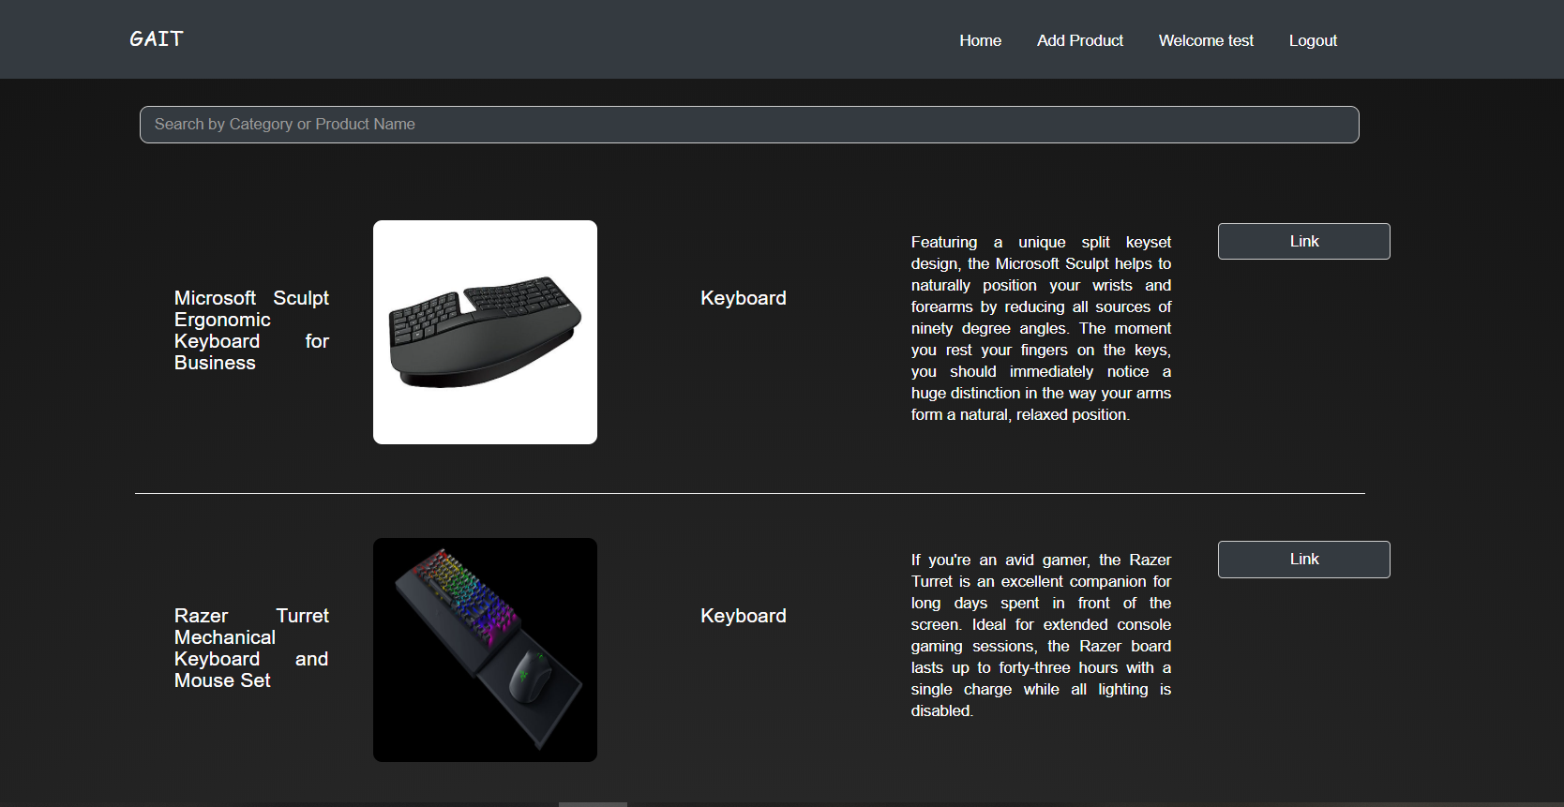

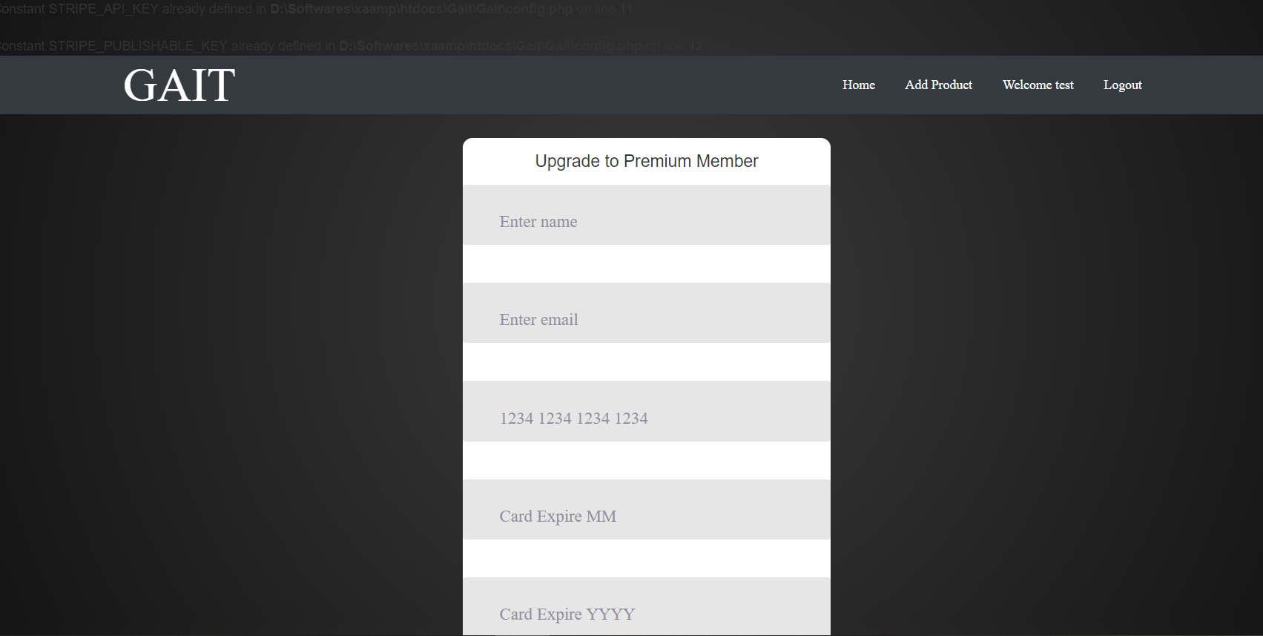Gait also offers a payment method for premium membership. This feature was implemented using Stripe API which takes user’s details in a form as shown below and then registers the user as a premium member by updating the User table in the database.

## 

## Back end development

The back end handles much of the verification and authentication process. The database stores the information of the users and the products, including their details. The back end provides the password verification and ‘forgot password’ feature. The ER diagram below visually demonstrates the relations in the database.

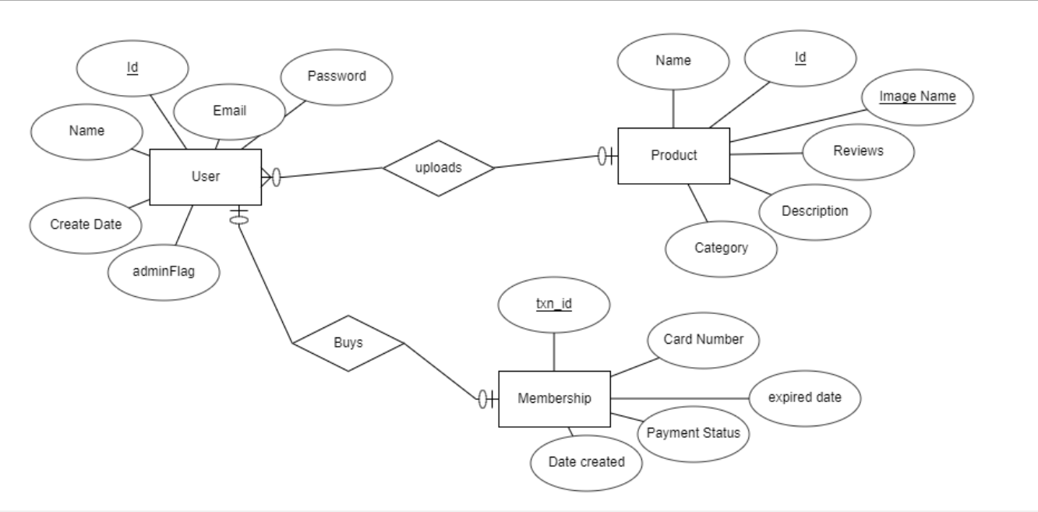

## Performance plan:

### **Open-source web page tester**

* We run the website in both using GTmetrix and Webpage test. In GTmatrix it scores A (90%) in page speed. The YSlow score is 76%. In webpage test it failed in security code and cache content. Though we can’t use CDN for the lack of resources.

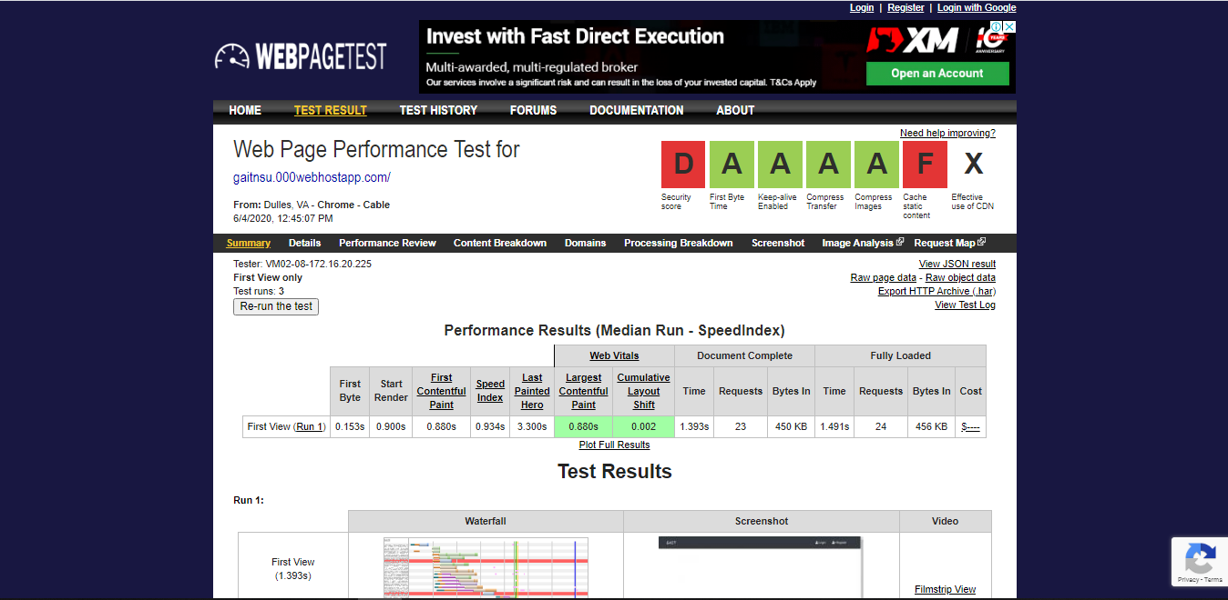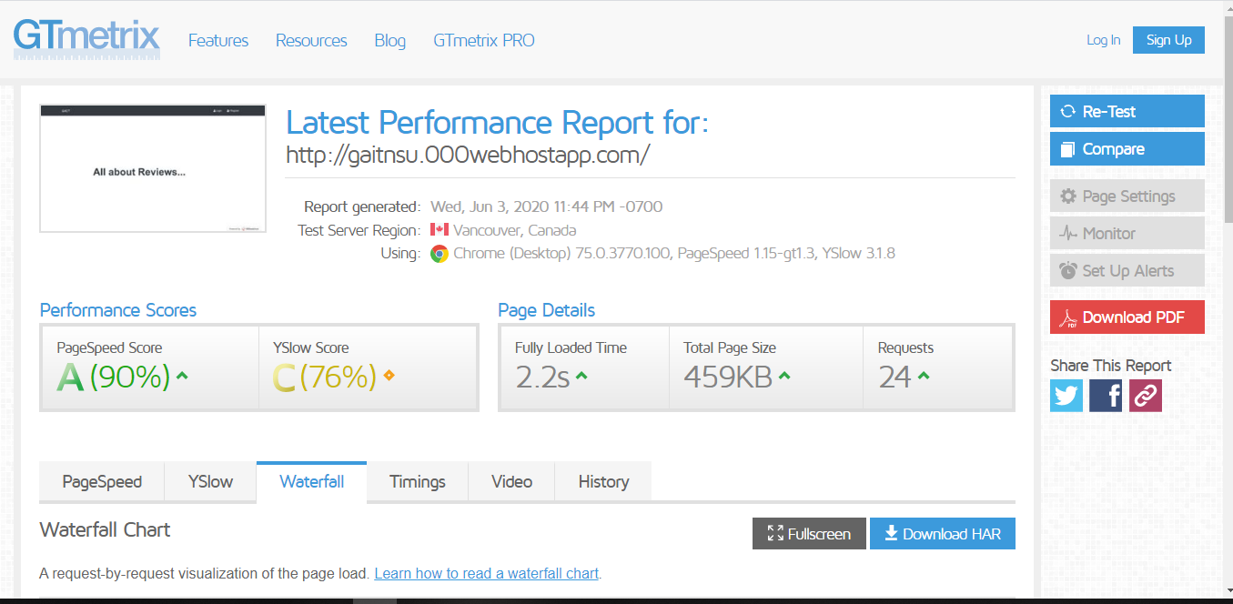

### **Google Page evaluation**

* In the Google page speed insights it scores 95 in desktop version and 80 in the mobile version. So we consider it that the website runs effectively.

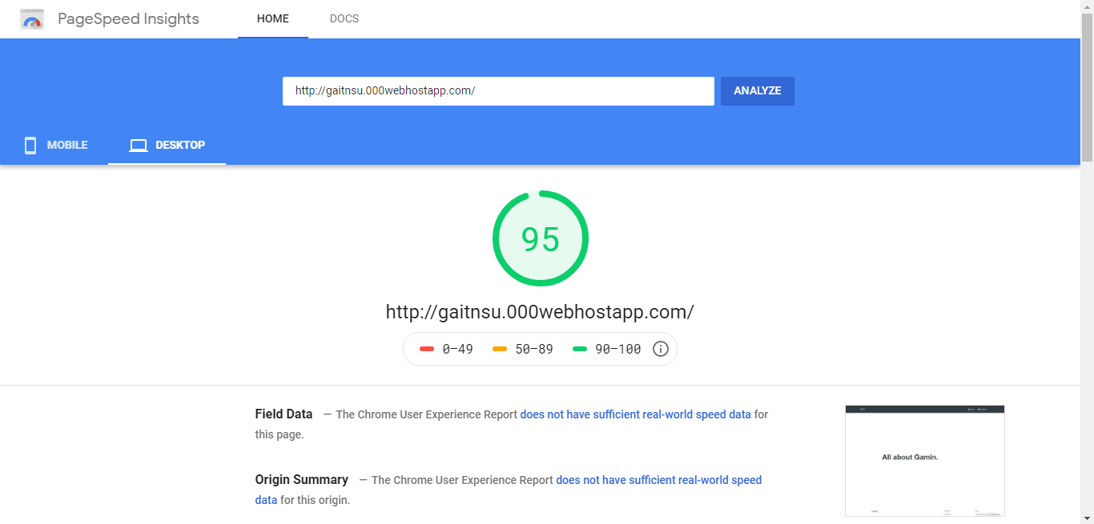

# 

# Development Plan

Development stretched over 8 weeks and was divided into two parts for convenience.

Development methodology adopted the agile methodology. Each cycle were completed in exactly 2 weeks (10 working days). At the end of each cycle, developing team released a working software version. The platform planner team, UX designer team and the developer team ran the software, tested and provided their feedbacks vice versa.

## Phase 1

Duration: 3 weeks. In this phase the entire front end was roughly completed. We released a complete website with acceptable performance and user experience.

## Phase 2

Duration: 5 weeks. In a span of 5 weeks the developing team tackled the back end. This meant creating the database and establishing connection. Furthermore, user login authentication, Payment API integration was implemented. Finally, the website was hosted in 000webhostapp.com.

**Hosting Plan**

We use 000webhost for hosting this site. For the lack of resources, we use free hosting for our website. 000webhost provides a free domain and hosting. The current hosting is located in US but in the future it can be moved to Singapore which is much closer to customer’s region and this will decrease latency.

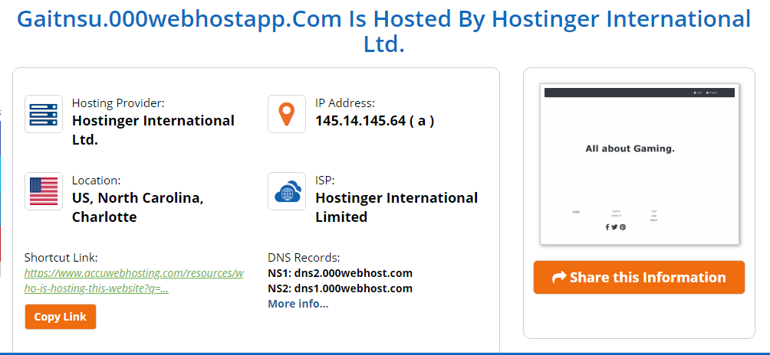

**Collaboration Plan**

The following table demonstrates the bulk of the project work divided into parts and the group members who were assigned to finish each of the task in due time.

|  |  |
| --- | --- |
| **Tasks** | **Assigned Member** |
| Front end- homepage | Ishrat |
| Front end- admin panel | Sazid |
| Frontend – product page | Arif |
| Frontend- profile page | Farhanzuzzaman |
| Database schema | Ishrat |
| Backend – Payment API | Ishrat |
| Backend – Admin panel, Product page | Sazid |
| Backend – Profile | Farhanzuzzaman |
| Web hosting | Sazid |
| Documentation | Ishrat, Sazid |

# Project schedule

Since the project was fairly big, the development plan was to divide the work load based on the components of the project and schedule it within the time frame of 8 weeks as the below table demonstrates.

|  |  |  |  |  |  |  |  |  |
| --- | --- | --- | --- | --- | --- | --- | --- | --- |
| **Deliverables** | **Week1** | **Week2** | **Week3** | **Week4** | **Week5** | **Week6** | **Week7** | **Week8** |
| Front end |  |  |  |  |  |  |  |  |
| DB connection |  |  |  |  |  |  |  |  |
| User authentication |  |  |  |  |  |  |  |  |
| Search option system |  |  |  |  |  |  |  |  |
| Web Hosting |  |  |  |  |  |  |  |  |

**Conclusion**

Gait is a state of the art solution for the modern time problem of Game accessory shopping. Our website makes it easier for those who take arduous measures to excessively go through reviews and available products to handpick the best suited one for themselves. It builds a community of gamers alike and a database of the best sellers and best performing gaming products. This saves time and reduces complexity.

The future prospective allows massive improvements and features to upgrade the user experience even more. The website could be shifted to a better hosting plan, more features such as reviews and commenting could be added and so on.